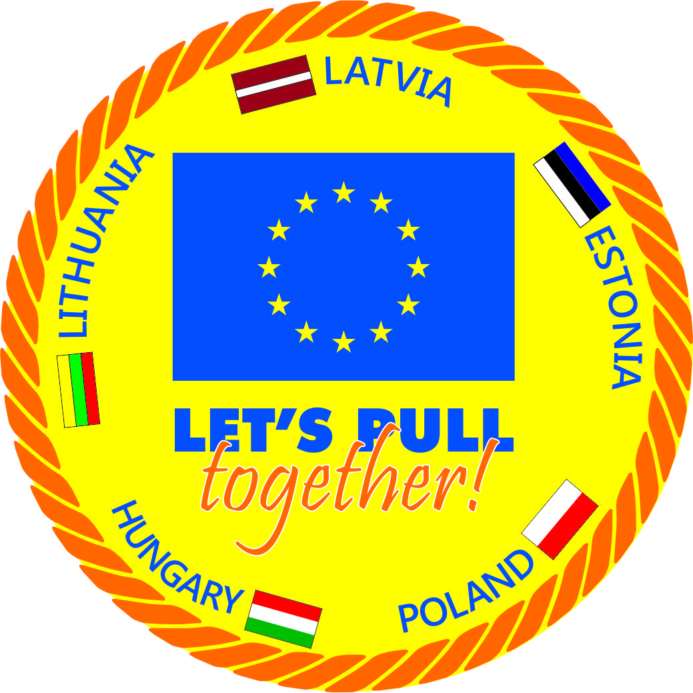 Project supported by European Council – EAC-2012-0559

**2 nd semester Preperation meeting in the frame of project „ Let’s pull together” according the EAC proposals**

(calls for proposals 2012 - Trans-frontier joint grassroots sport competitions in neighboring regions and Member States. – EAC – 2012 – 0559)

Sylwestra Kaliskiego str.2

Warsaw, POLAND

Poland , Warszawa ,

December 13-15th, 2013

At the end of semester one in November of 2013 an semester two preparatory meeting will take place in Poland in which 4 people from Latvia and two from other participating countries – 10 in total will take part. In the meeting preparations for the conference and Big Tug of War competition in May will be made, good practice handbook discussed.

**Participants :**

**Estonian MS Rugby club**

1. John Slade,

2.Oksana Beregova

**Lithuania Tug of War federation**

1.Giedrius Grybauskas

2. Eugenius Deksnys

**Hungarian Tug Of War Sport Association**

1.Peter Pipo,

2. Diana Salimova

**KIME Training & Promotion Center**

1. Dariusz Bajkowski,

2. Irenevisz Krisowaty,

**Latvia Tug of War federation**

1. Dzintars Polna,

2. Dace Radzina ,

3. Lilita Mūkina,

1.

**Programm**

**December 13th 2013.**

Until 16.30 Participants arrival

Coffee

17.30 Welcoming; meetings tasks and programm, record minutes

About Sport Forum in Vilnius - G.Grybauskas

18.00 Important for International job and ERASMUS 2020 ( presentation)

20.00 Diner

21.00 Cultural event

**December 14th**

**8.30 Breakfast**

**9.30** Steering comitee current situation projects implementation - presentation

**10.30** Content for EAC – 2012-0559 Project “ Let’s pull together” “ God practice Hand book” content

**11.00**  Coffee break

**11.30** Continue discussions

**13.00** Dinner

**14.30** Planning - Events 2014 May 2 - 4th in Riga 2nd May International group meeting – preparation for conference and project final - evaluation phase

3rd May Conference – content, finances ect.

4th May Big tug of War

Projects “Let’s pull together” conference (Closing international – cultural event)

16.00 Coffee break

16.30 Continue Workshop

19.00 Dinner

15trh Of December

8.00 A summary of recommendations for policy makers on how to most effectively use sport as a vehicle for personal, professional growth and social inclusion between youth of different backgrounds

1. Lunch

2.

Programm

1. Request Oksana Beregova to record minutes.
2. Confirm 12th October minutes
3. Discussins relflect to Hnadbooks content :

3.1.Information EC Sport forum and projects presentation.

3.2.Projects implementation - presentation – project results and deliverables

1. Planning - Events 2014 May 2 - 4th in Riga 2nd May International group meeting – preparation for conference and project final - evaluation phase
2. 3rd May Conference – content, responsibilities, finances ect.
3. 4th May Big tug of War
4. Projects “Let’s pull together” conference (Closing international – cultural event)
5. Recommendations for policy makers

**Meeting minutes records:**

1. Confirm Oksana Bergova to record meeting minutes.
2. Confirm 12th Octobes 2013 meeting minutes .

3.Discussins relflect to Handbooks content

Discussions - How and whether we as partners have achieved the project deliverables during seminars – discuss about terms ( Partnership – Tug of War as a vehicle for professional and personal growth for youth volunteers – future referees, organizers, *organisers and referees will organize a Tug of War competition* Project will create a sustainable international network ect.

Keeping in mind the above mentioned, the project has specific objectives:

* Promote Tug of War sport as a vehicle for professional and personal growth for youth
* Social inclusion and transcultural understanding between youth of different background.
* Gain management, organizational, referee skills using informal education, and make them promoters of tolerance and social inclusion.
* Build a sustainable network of Tug of War organizations and federations which using good practice examples and transferred knowledge will educate and train new youth volunteers, organizers and referees giving them practical knowledge.
* Organizers of different nationalities will give the volunteers an opportunity to grow both personally and professionally becoming more adaptable and improving their employability.
* Foster cross cultural understanding, tolerance and respect between youth of different backgrounds
* Exchange good practice examples between Tug of War organizations

**Discuss about good practice handbook content:**

**What necessary in Handbook?**

1. Information about project
2. Information about Tug of War
3. Tug of War volunteers training – education.
4. Project partners seminar’s reports
5. Special information interculturale education; international network

**Discuss content for Hand book**

1. Information about project:

1.1.Participants ( countries, figures, volunteers, cities, partners)

1.2.Aim of project

3.

**2. History of TWF, What is TW?**

2.1.Defination;

2.2.History

2.3. (TWIF WEB page lgo)

**3. Tug of War**

3.1.Methodics, Equipment, Security ( photos with mistakes), Program ( 1st step coaching with explanation ) , Tug of War team and training

3.2.Competition organization ( diferent levels – local, for children, with big participants amount, indoor, outdoor,) *( Not International level)*

**4.International network / 5.Intercultural learning**

What was goals before and after results

How we brought bareers wetween us.

How we get participants to the seminar

*Culural traditions, languages*

*Sport International language*

*Form to young people healathy life style*

*Enviroment clean, respect each ahnother ( TW)*

Web pages, contacts, promotion future,

**5.Partners reports :**

Five seminars reports - expeirence from partners – Latvia, Lithuania, Estonia, Hungary , Poland

Include : Seminars information – content , analize, interculturale, informal education

Internatinal group ( *Experets – expeirence – story* - *Voluntweers story – what I got , learned ( 1-A-4)* *Photos )*

**5.1.Project summary report – expeirence**

**5.2.Proposals for Policy makers**

**6.Annex:**

**TWIF roles** , Recording sheets, competition conditions

*For parners request 01.02.2014*

1.02. Experets – expeirence – story ( 1 A-4)

Voluntiers – what I got , learned ( 1-A-4)

1.02. Federations logos,

1.02. Sponsors logos ,

1.02. –Web pages

**Confirm Content for EAC – 2012-0559 Project “ Let’s pull together” “ God practice Hand book” content**

4.

1.Introduction – project manager

2. Tug of War - place in hand book - Latvia Experts with international group support

3.Intercultural learning ( include events in countries and partners expierence )

4.International network - ( include events in countries and partners expierence )

5.Partners expierence ( Each partner – qualitative and quantitave )

6.Project summary expierence

7.Proposals for Policy makers

**4. 2nd of May – arrival untill 14th – Mangers meeting**

Conference preperation;

Projects deliverables – eveluations ( int.group, conference, Big tug of War)

**5.Confirm conference programm: ( compose programm 11.-- 15.30)**

Riga City welcome

Europen Parlament deputy welcoming

Latvia Ministry of Education welcoming – state sport secretary

Guest’s greetings

Lithuania Tug of War federation report

KIME sport and promotion center report

Hungary Tug of War federation report

Estonia Multi sport club report

Latvia Tug of War federation report

Projects final report

Crosbord cooperation and interculural learning

Informal education in the sports

Proposals for sport policy makers

„ Good practice hand book opening

Closing of the conference

Interculturale evening

6.Big Tug of War event

6.1.Invite to participate in conference Partners countries Responsible ministries and Municipalities’ representative as well Embassy representatives in Latvia.

6.2.LTWF providing invitation letters (January – and end of March) – copies sending to partners.

6.3.Participants lists April 1st introduce Latvia TWF – 15 participants – volunteers from seminars partucipate in Conference.

5.

6.4. Speach – each partner – ilustrated presentation about project – each country 20 minutes

6.5.For International Dinner – each countey prepare some game, song , dance

6.6. 4 th of May – Participate volunteers in event – international group – in instructors corpus

6.7.Control Press realises – links ( date story)

6.8.Prepare Speach – ilustrated presentation about project – each country 20 minutes

6.9.For International Dinner – each countey prepare some game, song , dance

6.10.Finacial staements – Project providing accomodation and transport to Latvia

**7.Proposals for Policy makers:**

* TWIF – marketing sports assistant,
* Cheap sport for all, team sport
* Integriation , sport take people together, youth – Africa
* Accept informal education programm – volunteers
* TWIF tray projects
* Goverments – must be more opened to the non – plympic sports and national federations
* Exchange programms, informal education for wolunteers.

1.OPEN NON OLYMPIC SPORTS

2.ACCEPT INFORMAL EDUCATION PROGRAMMS

3.MORE OPEN INTERNATIONAL FEDERATION TO NEW FEDERATIONS

4.EXCHANGE PROGRAMMS INFORMAL EDUCATION FOR WOLUNTEERS.

Record : ________________________O. Bergova

Estonian MS Rugby club ________________________J.Slade,

Lithuania Tug of War federation _________________________G.Grybauskas

Hungarian Tug Of War Sport Association _________________________P. Pipo

KIME Training & Promotion Center __________________________D. Bajkowski

Latvia Tug of War federation __________________________Dz..Polna

6.