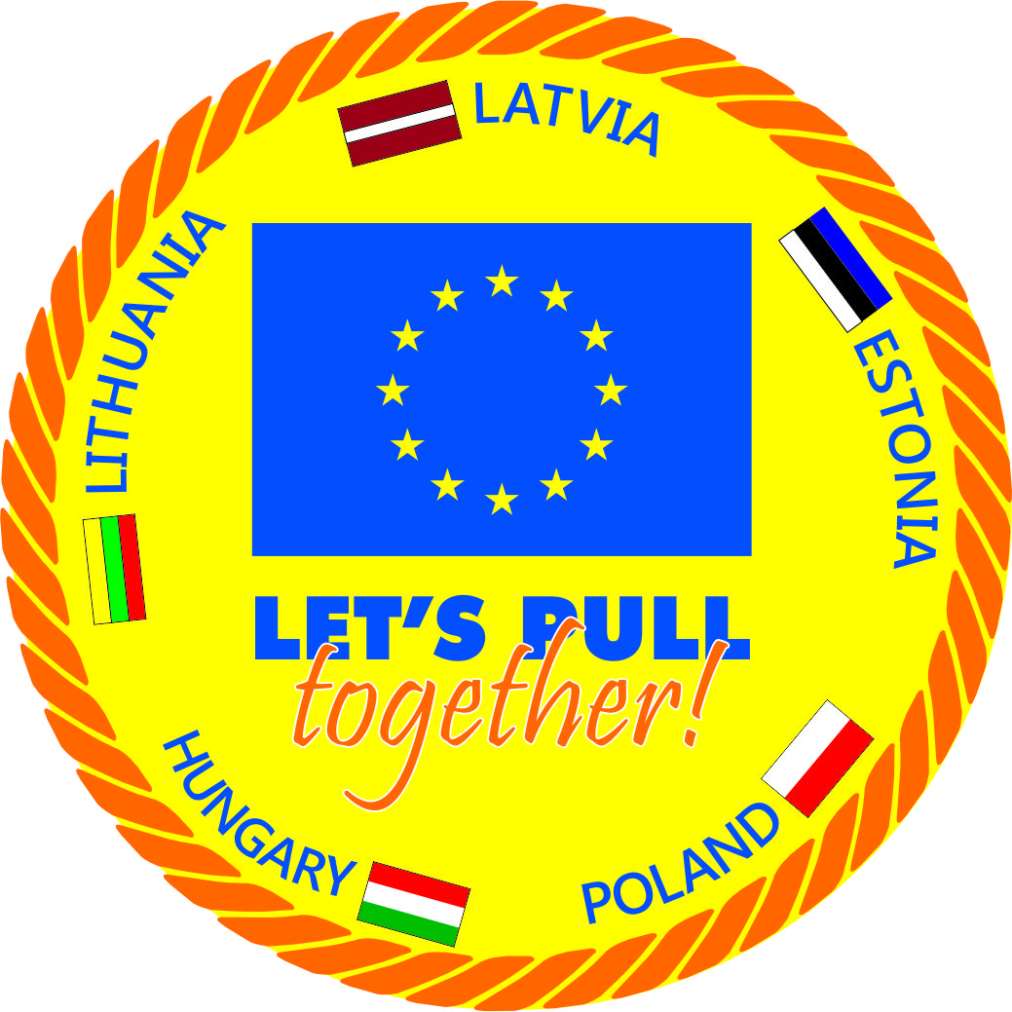 Project supported by European Council – EAC-2012-0559

**Projects preperation meeting „ Let’s pull together”**

Lithuania,

Kaunas March 8-10, 2013

**Aukštaičių str. 55,  LT 44162 KAUNAS Hotel „Sfinksas“**

**Participate :**

1.Lithuania G.Grybauskas, A.Zadeikyte, D.Černiauskas;

2.Hungary - P.Pipo, B.Pipo;

Poland - Z.Pabiszczak, K.Zabielski;

Latvia - L.Mūkina, D.Radziņa, G.Stahovska, A.Brākmanis, Dz.Polna;

Estonia - Piret Granovaskaja, John Slade

**PROGRAMM**

**March 8**

16.30 - 18.30 Welcoming; Project’s partners organizations presentations

18.30 Dinner

20.00 Intercultural events, team building

**March 9**

9.00 - 10.45 Project „ Let’s pull together” manegement methods and administrative questions (organiztion, administration, responsibilities, PR ect - presentation.)- partners pesponsibilities

10.45 – 11.15 Coffe break

11.15 - 13.00 Project „ Let’s pull together” manegement methods and administrative questions (finacial and accounting roles)

Good will ; Comunication betwen partners, international expert group comunication, Payments transfer roles, projects PR matherials, funding.

13.00 - 14.15 Lunch

14.15.-16.00 Project „ Let’s pull together” manegement methods and administrative question**s**

(Sreering comitee ; WEB conferences)

16.00 - 16.30 Coffe break

16.30 - 18.30 „ Let’s pull together” - seminar’s timetable sinhronizing

(Future seminars and competition planing. (organisation, content, programm, matherials, equipment, participants, steering grouo, international experts group)

19.30 Dinner

**10th of March**

**9.00** Discussins and questions**;** Finalize agreements- ptotoccolig, Partnership agreement -discussions**.**

11.0 0 - 11.30 Coffe break

11.30. Attendance Lithania Indoor Tug of War Championship

**13.30 .** Lunch

**Minutes**

**1.The seminars in five countries and the second preparatory meeting of the organizat**ion.

Resolved: To approve time table organizing the seminar. The second preparatory meeting of the organization to determine organize in Poland.

* **Five seminars/competition in countries- meetings 2013** /**2014**
* Confirms seminar venue, date, time, under the EAC/2012/0559

Latvia 17.-19.05.2013 - Ventspils

Lithuania 31.05.-02.06. 2013.- Palanga

Estonia Valga or Tallinn 04.-06.10. 2013

Hungary 16-18.08.2013. Szekesfehervar

Poland 11-13.10. 2013Warszawa

Poland – preporaty meeting for 2nd semester 6-8.12.2013

Conference and Big Tug of War – 2-4th May 2014, Riga

**2.Seminars organization – pertners responsibilities**

Administrative (agreements, forms which partners using during project events – participants list, sheets ect. public in the WEB, filesdocumentation for each event, correspondence, accounting, coordination, information, mails, correspondence, data– Latvia Tug of War federation, reports to EAC Personal ; Latvia& partners– agreements that determines the co-operation of the project's; Accounting ( transfers, invoices, bills, bank, documentation, taxes, research situation in countries); Financial ( partners founding – each country define a similar paid, except Latvia; reduce the staff costs by 10%, if some positions will be higher. In first place to make high –quality seminars and finally issue a good practice handbook.

Each country is responsible for your country to determine the law applicable to payment of staff costs and taxes paid. Each partner will receive fee for transportation costs to seminar in other country, in case if LVVF if not purchased a centralized all together – will be matched with the most efficient and effective option.

**3. Project management – partners:**

* 1 manager;1 stearing comission, 2 persons for expert group (one coach, one judge)
* Provide: facilities for semnar room, practical part -sport hall, graund,competition area
* Aaccomodation, meals, transport volunteers seminar participants (30) competition participants – teams ( 10-12), PR in countries – with muncipalities, Intercultural education in country; Coordination – comunication with project administration group, provide documentation , involved in the hand book’s content preperation, involved in the 2nd semester events; provide finansial input – funding.

**4. International expert’s group provide:**

* Seminars – content, programm, matherials, handauts, list of participants, sertificates, diplomas, competition documentation(program,protocols, conditions); Seminar and contents evaluation (forms), collecting mateherilas for hand book , Participation in seminars (from each country 2 pople participate in all seminars – possible change; Intercultural expierence

**5.Risks** Strategic risks - who also have experience; with youth work and informal education; Operative risks, Financial risks, Administrative risks.

**6.Project results** train 150 volunteers in 5 countries; organize a Tug of War competition 100 participants in country ( 10 teams), “Big Tug of War” – contest, create international network , good practice handbook , Interculturale expierence, Sustainability of the project

**7.Duscuss about:**

7.1. Partner responsible manager in charge conducting volunteer’s for each seminar.

7.2. Volunteers -seminar participants to acquire the knowledge and skills to strengthen competition, which may participate as organized team, seminar participants (in order to better learn the technical and tactical skills), as well as randomly members who wish to participate in the event. Competitors and teams was rewarded.

7.3.Each partner state shall ensure that measures providing information about the country, the place where the seminar takes place (culture, history, traditions, ceremonies, catering and other information)   
International group experts presentations will be reflected in the project venue - the city, country maps, sayings projects in their national language.

7.4. Partner website shall provide to the displayed content, linked to the local press, press releases needed in the local press about the event. Municipalities’ be notified and national sports bodies.

7.5. About the project source language set to English language, but the use of all others including the Russian language, which manages all the basic project members.

7.6. Documentation examples will be set in Latvia Tug of War federation homepage [www.lvvf.lv](http://www.lvvf.lv)

**8. Financial statements:**

**8.1. “ Good will” memorandum :**

The project participant "Undertakes to participate in the project" Let `s pull together" behind voluntarily, without fraud and error. Project participant confirms that the project is not designed to make a profit, but a member of this project will contribute to the development of Tug of War, visibility, growth and educational opportunities that are connected with a rope tow. The undersigned certifies that its presence will participate in all events; seminars will be organized and will provide co-financing under the Treaty EAC/S06/2012.

8.2.The seminar venue organizer shall inform the Latvian Federation of tug of war 30 days in advance of the seminar start date for the expenses that will be required to organize the workshop- market research suld be provided during previous seminar and confirmed by steering comitee

8.3. Payments-Invoices for the organization of the seminar will cover Latvian Federation of tug of war - within 5 days after receipt of the invoice from the project participants. Will be paid for only those bills that a member of the project board in Latvian tug of war on the Federation seminar organizing services, pre-agreed amount of payment. The parties may agree that the bills can be paid on the spot - a particular seminar venue. All invoices will be paid only by bank transfer, no cash payments.

8.4.The amount of expenses related to transport - getting to the workshop venue and back, specify (agree on the amount of costs) Latvian Federation of tug of war and the participation of each project country, 30 days before the event period. The parties agree on the most economical option - under the Treaty EAC/S06/2012.

8.5. Funding distribution by partners

8.6. LTWF providing for participants diplomas, pencils, pens, T shirts , badges, sertificates, posters – banner

**9.The Steering committee**.

9.1.A steering committee will be formed (consisting of one representative of each country) supervision of the operation and risks  
Resolved: To approve the steering committee consisting of five members from each country a representative.

Steering comitee

* Dzintars Polna - LTWF
* Giedrius Grybauskas - LtTWF
* Peter Pipo - Hungary
* Dariusz Bajkowski - Poland
* John Slade - Estonia

9.2.Steering Committee determines seminars and consider issues related to the seminar content, presentation development, security, funding, financial statements and other issues arising from the project implementation process, based on the recommendations of the partners in the proposed persons are subject to change.  
  
**10. The international expert’s group composition**

10.1. The international group of experts participating in the seminar improve content of the project and meet the objective, through experience, knowledge, skills acquired in sports, at work, in the learning process

10.2. Latvian experts prepare presentations to hold workshops content. These are improving According to the evaluation and monitoring committee recommendations.

10.3. The expert group prepares a workshop content and choose pedagogical methods and tools (formal and informal) to be applied in acquiring content. All project documentation are documented for each measure creating a document folder, based on the circulation of documents. International line-up changed in accordance with the appropriate human resources (quality) in the country where the event will take place - the judges, skilled athletes. Each seminar will assess and identify participants  
  
10.4.Composition of the group is coordinated in accordance with a partner, where the seminars and group members are aware of the challenges that they will have to measure.   
  
10.5. Latvian party shall notify all members of the International Panel on the location of seminars, programs, arrival time and arrange group insurance (tickets)

10.6. Web conference organizers when necessary.

**International expert’s group :**

***Aivars Brakmanis – coordinator***

* Ainars Zablovskis, Raivo Tuka – coaching
* Dzintars Polna – judging - referee
* Aivars Dukats - support
* Aleksandrs Shalajevs - support
* Hungary - Peter Pipo
* Hungary - Lajos Vörös
* Poland – Darius Bajkovsky
* Poland –Zbigniew Pabiszczak
* Lithuania – Agne Žadeikyte
* Lithuania – Darius Černiauskas
* Estonia – Piret Granovskaja
* Estonia – John Slade

**11.The clothing and memorabilia for all workshop participants.**

11.1. Latvian partner, carrying out market research through acquisitions profitable organization, to ensure the relevance of the chosen material and technical resources to purchase.   
  
11.2. All participants in activities in the partner countries to provide funds for the project Latvian side.   
  
11.3. Latvian side in the development of methodological materials, uniform documents, document circulation system, which is used for its implementation.   
  
11.4. The documentary side and organization of events provides a partner who organizes a workshop project.

11.5. Project design material in accordance with the partners Resolved: Provide polo shirts. Color - blue. Sizes M-women, men-XL, pens, pencils, note books, badges

**11.6. The international group trips to seminars**.  
Resolved: To plan and submit any travel expenses, as well as to indicate possible means of transport to be able to make timely payments.

Latvian party pays for the tickets to Partners or LVVF centrally purchased a ticket to international partner countries in the group. Planes use if find more economical and see particular partners circumstances - all partners employd. Provide that partners could participate in all seminars events.

**12.The five-country partners cooperation agreement.**Resolved: Sign the contract, after the correction and before events held in partners countries

*A dedicated project web page will be set up – each partner*

All workshops will be entered in the Documentation, the corresponding document system

Record LTWF Dz.Polna

Representatives sigantures: G.Grybauskas

Z.Pabiszczak

P. Pipo

J. Slade