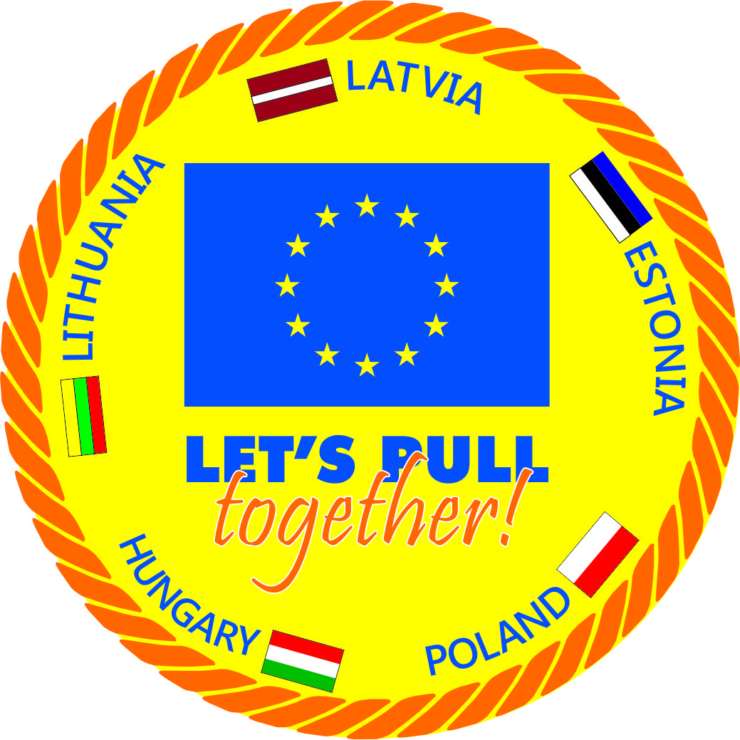 Project supported by European Council – EAC-2012-0559

**Steering comitee meeting EAC – 2012 – 0559 „ Let’s pull together”**

**MINUTES Nr. 1**

PROGRAMME „ Let´s pull together”

Ventspils Olympic Center, Sporta iela 7/10

**May 17th, 2014**

12Lunch

12.30 Introduction, international group tasks during the seminar, team building (Preperation for seminar)

**Seminar** (Participation in the seminar and involment in activities)

15:30 to 16:00 Registration of participants.  
16:00 to 16:15 – 30 Introduction (involvement in the presentation).

Opening of the workshop and dating.  
16:15 to 16:30 Tug of War sport in the World and Latvian  
16:30 to 17:00 Tug indoor team building, training and preparation  
17:00 to 17:20 Tug of war competitions premises - characterization and organization, team  
activity.  
17:20 to 17:45 Tug of War contest rules, judging competitions (indoors and outdoor).  
17:45 to 18:00 Break.18:15 to 19:15 Practice premises -by all workshop participants ( Involvement in activities – group creating)   
19:15 to 19:45 Discussion and questions ( Involvement)  
20:00 Dinner.

21.00 meeting – first day evaluation and tasks for 2 nd day

**18.05.2013**08:00 to 09:00 Breakfast.

Preperation - intrenational group

Involment in 2nd day „ worming up” game ( use your language), participation in seminar   
10:00 to 10:45 Rope pulling outdoor of team building, training and preparation.  
10:45 to 11:15 Tug of War competition outdoor organization.  
11:15 to 11:45 recording and its activities.  
11:45 to 12:00 Break.

1.

( Involvement in activities – group’ s creating)  
12:15 to 13:15 Practice outdoor (stadium) by all workshop participants.  
14:00 - 15:00 Lunch.  
15:00 to 15:30 Tug of War Sports General Administration characterization ( become judges, member) – learn next day competition roles

15:30 to 16:30 Discussion and questions. The division of responsibilities next day. ( Voluntary and International group)

17.00 – Adventures park and Beach park in Ventspils  
19.30 Dinner

20.00 Steering comitee meeting.

1.Project deliverables

` 2.International expert group special tasks

3. Financial management – next seminar

4.Informal education methods using during events

**19.05. 2013.**

07:0 - 8:00 Breakfast

9.00 Preperation for competition   
11:00 to 13:00 Tug of War contest organization, management, adjudication - a practice session workshop participants.  
13:15 to 14:00 Workshop evaluation and closure. Certificates, Diplomas, awrds, ( contract) International group eveluation   
14:00 - 15:00 Lunch.

**Steering comitee meeting EAC – 2012 – 0559 „ Let’s pull together”**

**MINUTES Nr. 1.**

May 17, 2013,

Ventspils, Olympic center

Participate :

Hungary_ **Peter Pipo,** Lajos Voros,

Lithuania - **Agnė Žadeikytė**, Darius Černiauskas,

Poland: **Kamil Zabielski**, Marttyna Gotebiewska,

Latvia: **Dzintars Polna**, Aivars Brakmanis, Guna Stahovska,

Estonia : **John Slade**, Sergej Nikiitin

**Discuss about:**

1.Project deliverables and seminar –competition organisation and administration – voluntary participants involvement in seminars.

The seminars have to pay attention to the results they need to realize the project goals

In the each country find most relevent target groups – students, military.

Seminar content during seminars could be improved.

2.

2..International group special tasks

Next seminar in the Palanga the International expert group to give specific tasks to a workshop course - to engage with both presentations about their country and volunteer training tug of war. Languages – find person whoes can translate presentations content.

3. Finacila statements for seminars – competition – important to hand in according agreement – 30 days before event, inform about events programm, place, financial statements.

3.1.After Market reaseach Lithuania Tuf of War federation find that all necesaary conditions to provide seminar – competition could provide organizer Palnga „ Palangos Vetra”

**4.Informal education methods using during events:**

1.”Introduce yourself”

2. "Vocabulary-building" during the seminars

3. Intercultural evening   
4. Taste other languages  
6 . Find your family

7. Mime

8. Map.

We can find our ideas.

**Steering committee:**

Latvia TWF ________________________Dzintars Polna

Hungary TWF _________________________Peter Pipo

Poland KIME sport promotion center _________________________ Kamil Zabielski

Estonia MSC Rugby club Tallinn _________________________John Slade

Lithuania TWF _________________________ Agnė Žadeikytė

3.

1.”Introduce yourself”

Purpose: To meet and present their state, county, express a desire to want to get in the seminar  
Meeting held each official language (dialect can be discharged)  
Requires: LATVIAN card and project card (international group), post-it notes 2 (pc) for each participant  
Participants before the seminar folder enclosed stickers 2 colors (or can be removed before starting dating)  
Dates:  
First task - to write a 1.lapiņas name, city, county, glued to the Post-it note on the map  
Second to "Wish tree" leaf member write what they want to get a seminar-member (knowledge, skills, coach, referee, organizer, friends, engage, etc.), also an international group and teachers are doing and will be glued to the drawn tree (before the seminar draws an international group of )  
Each participant, by presenting themselves, using their own language (the language of a nationality that he (a), first appearing in front of the driver activity and say the name, city and state from which he is, place of work, interests, what I want to get the workshop? (Exercise 1 in your language says - My name is ...... I'm from ......,....... I work for what I want)  
1.stick glued to the card (name, whence)  
  Second "Wish tree" sticky notes stuck to drawn "Wooden" and participants continue ...  
After doing all the other activities of the participants, and all posted as such this information. Each participant is given 30 seconds.  
(It may be a task displayed on the map of the place where the participant, to stick to the white pages - notes (Vidzeme Vidzeme, Latgale, Vidzeme, Riga), etc..

**2. "Timber Utilisation"**Objective: To promote a sense of fulfillment, the seminar made.  
Duration: 15 minutes at the beginning of the project, for 30 minutes at the end of the project.  
1st day of "Tree and expectations for the workshop evaluation" - each takes its leaf, and in the end the participants are invited to share experiences and compare it to what was intended before the seminar.  
  "Plus" another question for the assessment of future activities ... (profile)  
Finally - a participant writes a "contract", which he nearest 4 - 6 months to do the (envelope - blank page - I am committed to - what to do .....)  
Assessment.  
  
What did this, what did?  
  
That we can cooperate in the future - 15 large drawing and Conference

**3. "Vocabulary-building" during the seminars**  
During the workshop, build a small dictionary'' '- in the context of the content and make it interesting and so on.  
Key words for each state representative, and writes the "big block" option - English, Latvian, Lithuanian, Estonian, Polish, Hungarian - all seminar course develops vocabulary - with the creation of terminology.  
Can be used in teaching the tug of war team, a variety of languages. - Implicate the rules (previously prepared by the international group, involving them)

Let’s pull together!  
Please ....  
Thank you .....  
good day  
Uzredzēšanos  
The tug of war terminology.

**4. INTERCULTURAL evening** -  
Used to start discussions on the practice book pages with the International Group  
negotiate an international group - which form an important international contacts, cooperation, it is necessary to know while traveling to another country sports delegations.  
Sport and identity - I want to get the project? What should you know about the country, culture, traditions, laws, etc. going to gym visit?

They want to get during the project period – Istart to talk about good practice handbook contents....

**2nd day „Warm-up"**

**5. Taste other languages**Purpose: To lead the participant’s interest in other countries, their cultures and languages. (Preparing international group – some short text)   
  
Requires: Nothing  
Participants have to learn to count from 1 - 9 in each group member language, or other words.... You can make learn something else (eg folk songs / poems, but it is advisable to pre-prepare a page with text), such as pulling a team, notes, etc.. for example „ Let’ s pull together”

**CREATION ACTIVITIES - the largest group split into smaller.** (To be used in practical part of the next practical work on the ropes)

**6 . Find your family**Purpose: To divide the group in teams. (For international groups)  
Requires: cards with different names, countries  
Dates: Trainer distributed cards on which are written the names. Participants can watch, what their surname, just as coach signal is. Then the participant needs to find others who have the same name - teamed up in the same....

**7.Mime**  
Purpose: To divide the group into smaller teams.  
You need: paper pieces of words related with Europe.  
Conduct of the leader of the group of small slips of paper are printed with European names, flags (national titles, of which participate in the seminar), such as Hungary, Poland, Lithuania, Estonia, Latvia. When the participants have received this memo them, look for the other team members, representing the country and mention

**8. BIRTHDAY**  
Purpose: To divide the group into smaller teams.  
Requires: nothing  
Process: people who were born even days, agree on one team that odd - the second. Or share the following seasons, when the birthday (seasons into one group) is.

**9. SHOE SIZE**  
Objective: The teams split the people of novelty criterion.  
Requires: participants must be up shoes  
Process: it is necessary to choose the criteria that would be possible most unusual and original, but which would be divided into teams of people. For example a team of people to split the shoe size / color / material.

**10. Tug of War One to One**  
Requires: Rope, towers (or other object), marks on the rope (tape adhesive)  
Rope length and thickness of their own choice to make it easy to cover by hand - not too thin.  
  Highlight rope and the center line of the square.  
The rope marks put on where to park tractor cabin (1-2 m from the center)  
Tractors behind labeled "Square" - situated in grades pylons (1-2-3 m) away,  
which shall be passed over the rope.  
Tractor pulls - who first pulled the rope over and touching the back positioned marks  
  - towers. Possible held with several ropes in parallel.

**11. Tug of War the Cross**Requires 2 ropes  
Marked center line, rope placed on the cross - is pulling....